**Related App Review**

**When I Work – Employee Scheduling**

**Google Play URL:** https://play.google.com/store/apps/details?id=com.thisclicks.wiw&hl=en

**Screenshots:**

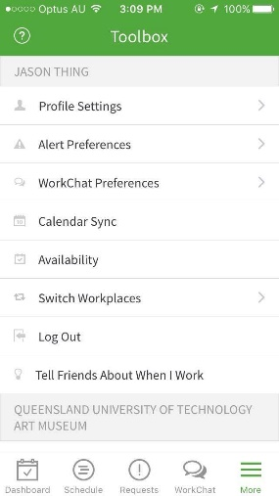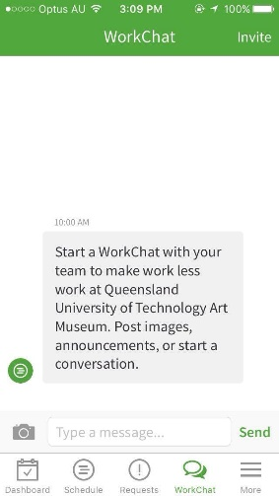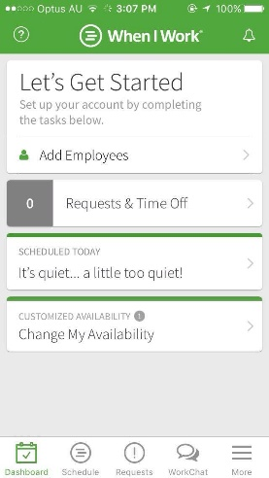

Extra Settings

Chat

Home page

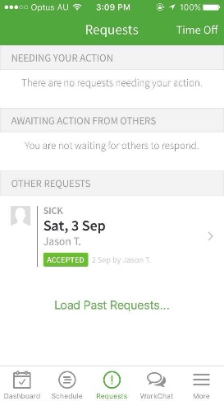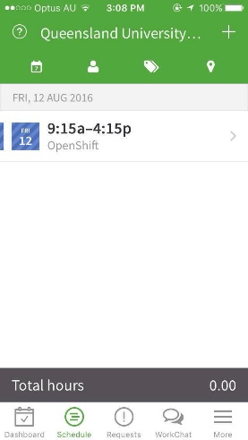

Requests Settings

Shift Settings

**Description:** When I work is a dashboarding/scheduling application designed for small to medium sized business, and helps employees and employers to manage their schedules and shifts.

**How to use**:

1. Opening the app will show the home screen of the app, giving users a view of the dashboard.
2. There are 5 tabs at the bottom, allowing users to tap and switch the screen to show either the schedules made, requests by employees, the in-built chat, and a settings screen.
3. The two main features of this app is to schedules shifts for employees. The feature however, comes with many other minor features to support it, for example allowing employees to request time off or change of shifts, and also allows users to view the availability of each other.
4. Shifts can be created in the dashboard, and users can choose themselves or other employees to assign to shifts.
5. The time for shifts can be changed anytime in the dashboard, and users can merely edit their shift by changing the time and date. Another good option is that users can also choose what type of shit will it be, e.g. unpaid break, sick leave and such.
6. Users can see the availability of other users, whereby users set their own available times in the dashboard too.

**Design & Interactivity**

**Positive**: Colour and theme of the app is consistent, all the functions and features are responsive and I did not experience and lags or crashes even when I tried creating up to 30 shifts.

**Negative**: The interface looks quite complicating, and it is safe to say that the app has little to no graphical design. It looks fairly complex for first time users, and may prompt users to feel that it is difficult to use.

**Features & Functionality**

**Positive:** It has a variety of functions built into it, and many of it applies to real life office situations. The request time out function is really useful for employees, and there are many sub-options in it such as the time, date, reason and such. Users are also able to modify their availability and shifts. One special feature of this app is that it allows users to create open shifts, meaning that any employee with similar roles are able to take up the open shifts.

**Negative**: Personally, I feel that the abundance of features itself may confuse users as it makes the app more complicated. Other than that, there are no real negative side of its features.

GoToMeeting – Meeting Scheduling

**Google Play URL**: https://itunes.apple.com/au/app/gotomeeting/id424104128?mt=8

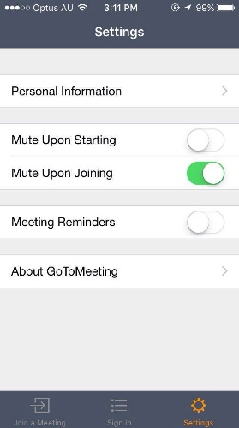**Screenshots**:

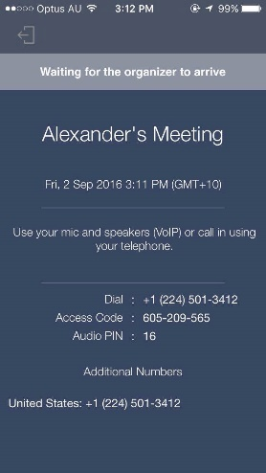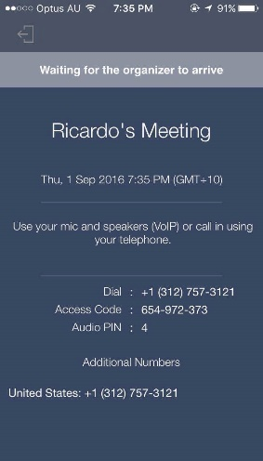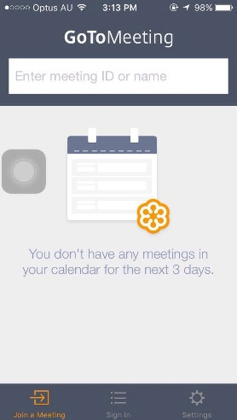

Meeting 2

Meeting 1

HomePage

HomePage

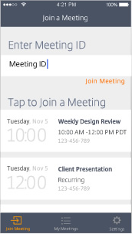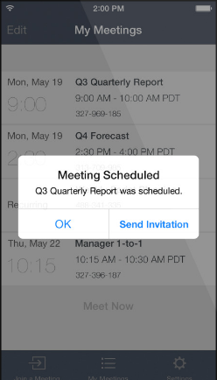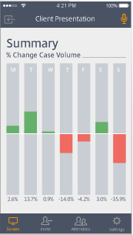

Meeting Sample

Schedule Meetings

Screen Sharing

**Description**: GoToMeeting is an app that allows users to join meetings and share files over the app. Not only that, but it has complex tools in place to also let users hold conference meetings with webcams, and also share screen to show presentations or slideshows.

**How to use**:

1. Opening the app will instantly bring users to the homepage which shows the scheduled meetings for the next three days.
2. Users can type out the meeting ID or name and join any meetings instantly.
3. The app syncs with the phone’s calendar, and this allows users to keep track of all meetings or events that they will have in the coming week.
4. Another feature for users is that they can directly sign in with their company ID, and this will sync all their details from their company.
5. Once inside a meeting, users can then choose to use their webcam or to share files in the meeting. Users just have to tap the arrow button and click share files or share screen.

**Design & Interactivity**

**Positive**: Overall, the app is really simple to use due to the interface which is well designed. At first look, the app looks really simple, but once users joins a meeting, there is a multitude of functions available for them. With only 3 tabs to navigate around, it makes it really easy for users to move around the app.

**Negative**: The app has some minor bugs for example when attempting to sign in, it crashed occasionally for me. When leaving a meeting, it may sometimes lag for about 20 seconds, which may be inconvenient for users. Other than that, there are no major cons about the app.

**Features & Functionality**

**Positive:** The developers had been wise to add features when inside a meeting. Allowing users to share slideshows and presentations inside the meeting is really useful, and users can also share their screen with other users. This app helps to save plenty of time compared to using other apps such as Skype, as Skype does not even support multiple webcam calls on mobile phones. Users could also share files among themselves as this app supports integration from cloud, dropbox and such.

**Negative**: As the objective of the app is to help users create and join meetings, I feel that it fulfils all of its objectives and only has some minor cons about it. For example, when having a webcam meeting with up to 6 people, the screens are really small and users can barely see each other. Of course, this problem is due to mobile phone sizes and not the app itself.

**Google Play URL**: https://itunes.apple.com/us/app/id981856216?mt=8

**Screenshots:**

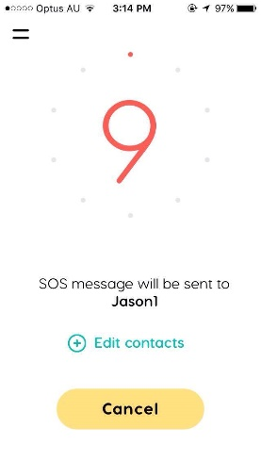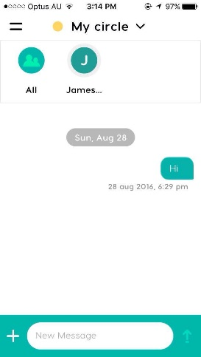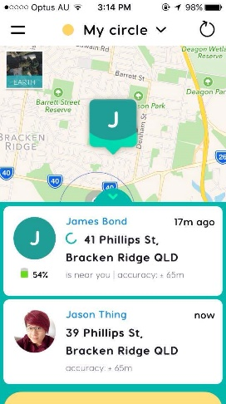

Home Screen

SOS Feature

Circle

HomePage

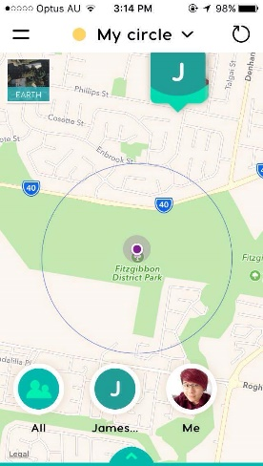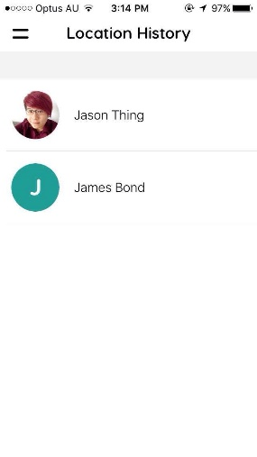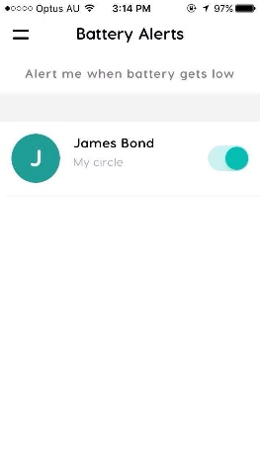

PinPoint Location

Location History

Battery Alert

**Description**: GeoZilla is the first AI-based GPS locator which helps users to share their location with friends and family, notifying them when and where they will be at a specific place. This app focuses on geographical locations and sharing it.

**How to Use**:

1. When the app is opened, it shows users a map. On the map, it shows where the user currently is, and where the locations of their contacts are.
2. Users can create circles and add members to it. Circles are made to provide more information for those in their circles, for example it allows users to see the battery life and location of those in their circles.
3. Users can then select specific places to pinpoint, and anyone entering or exiting that circle will prompt a notification for the user. For example, I have set a circle on a nearby park, and if any of my family members enters the park, I will be notified of it.
4. There is also an in-built chat system, allowing users to chat with other users in their circle.
5. There is a location history feature which allows users to see the previous locations of their contacts, and it even shows the time when they were in a specific location.
6. Emergency alert allows users to instantly send SOS messages to either their contacts or emergency services. Users just have to tap on the emergency alert tab and it will automatically send a SOS message in 10 seconds.

**Design & Interactivity**

**Positive**: The app itself is really simple to use, and I particularly like the interface as it is really user friendly. It is very easy to navigate around, and users can open up the navigation tab by just swiping to the right. The homepage of the app itself is the map showing users location and location of their contacts. The colour theme for the app is consistent.

**Negative**: Overall, I could find no faults in the interface and design of it.

**Features & Functionality**

**Positive:** The features of this app is very well thought-of, and I liked all of it. The “circle” feature which allows users to choose a location to view who enters and exit it is really useful, and it also relates to our app whereby we will be using beacons to track users rather than wifi and cell towers. Responsiveness of the app is very well, as there are no lags whatsoever. The app also features a battery saver function, which helps users to save battery. Allowing users to refresh the location of their contacts is so much more battery-friendly, and this app could last me a full day without charge compared to other location tracking apps which drains battery quickly.

**Negative**: In my opinion, I could see no negative areas of this app. Everything has been built very nicely and the functions were well thought off. The only disadvantage may be the number limit of people that users can add to their circles. Users would have to pay a small fee of 0.99$ to increase their limit of users.

**\**